Task 2 – Creating users
Microsoft Azure doesn’t allow me to create users as Sown in the picture so I am going to list the steps I would have taken.
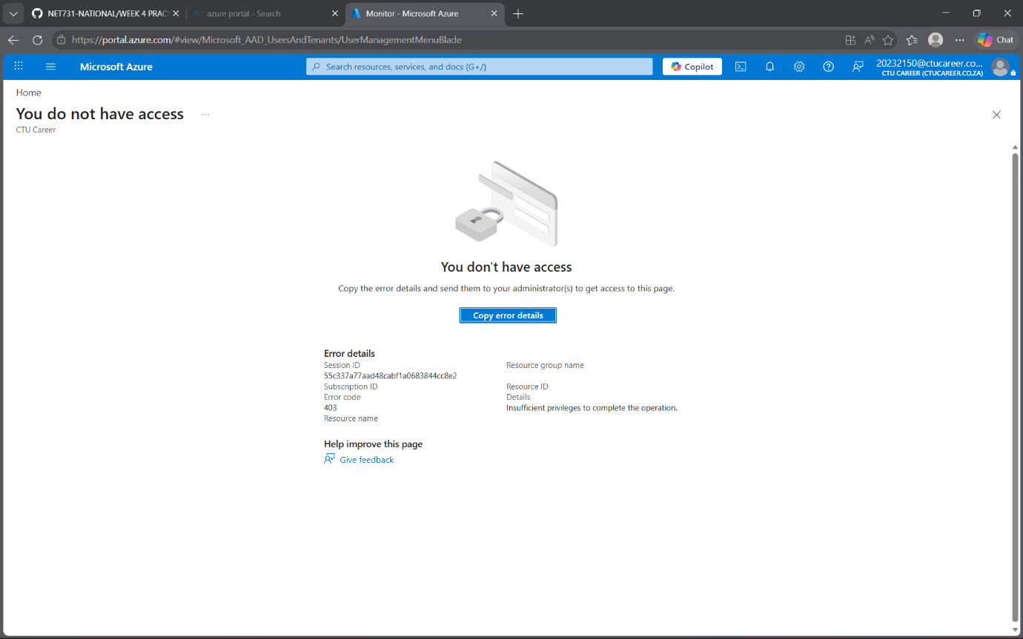
Task 2a
• Navigate to Azure Active Directory
Then go to Users then + New user.
First user:
Display name: Alex
Username: alex@yourtenant.onmicrosoft.com.
Department: Development
Job title: Developer
Password: **********
Second User:
Display name: Johanna
Username: johanna@yourtenant.onmicrosoft.com.
Department: Development
Job title: Dev Ops Engineer
Password: ***********
Third User:
Display name: Roselina
Username: roselina@yourtenant.onmicrosoft.com.
Department: Operations
Job title: Operator
Password: *********
Fourth User:
Display name: Amelia
Username: amelia@yourtenant.onmicrosoft.com.
Department: Operations
Job title: Operator
Password: *********
Fifth user:
Display name: Gladness
Username: gladness@yourtenant.onmicrosoft.com.
Department: Finance
Job title: Finance Analyst
Password: *********
Sixth User
Display name: Charity
Username: charity@yourtenant.onmicrosoft.com.
Department: Finance
Job title: Financial Intern
Password: *********
Task 2b
In Azure Active Directory,
Go to Groups then + New group.
Create three groups:
First Group:
Group Name: proj-orion-dev
Membership type: Assigned
Add user: Alex
: Johanna
Second group
Group name: proj-orion-ops
Type: Security
Membership type: Assigned.
Add users: Roselina
: Amelia
Third group:
Group name: proj-orion-finance
Type: Security
Membership type: Assigned
Add users: Charity
: Gladness
Task 3
Go to your Resource Group.
Select Access control (IAM) then + Add role assignment.
Assign roles to groups:
proj-orion-dev → Contributor
-Developers need to deploy and manage resources but not grant access.
proj-orion-ops → Reader
Operations team needs visibility into resources but should not modify them.
proj-orion-finance → Reader (Billing scope)
Finance team requires access to cost and billing data only.

